Hotel Bookings Dataset
Data Cleaning & Pre-Processing Report
A detailed account of the methods, transformations, and validations applied to prepare the hotel bookings dataset for analysis.
119,390  Original Records | 32  Original Columns | 87,203  Final Records | 36  Final Columns | Python  Tooling
Source File: hotel_bookings.csv | Tooling: Python, pandas, matplotlib

1. Overview
This report documents the data cleaning and pre-processing workflow applied to the hotel_bookings dataset, a collection of booking records from two hotel properties (a City Hotel and a Resort Hotel). The raw dataset contained 119,390 records across 32 columns. The objective was to identify and resolve data quality issues — missing values, duplicate records, invalid entries, and statistical outliers — and to convert columns into appropriate data types. Feature engineering was then performed to derive additional useful attributes. The final, cleaned dataset contains 87,203 records and 36 columns.

1.1 Processing Pipeline
- Data Exploration — inspect shape, data types, summary statistics, and missing values
- Missing Value Treatment — impute or drop columns/rows with missing data
- Duplicate Removal — drop exact duplicate records
- Invalid Record Removal — remove zero-guest bookings and negative rate values
- Outlier Detection & Treatment — identify outliers via IQR, cap extreme values
- Data Type Conversion — convert categorical columns, fix numeric types, build a date column
- Feature Engineering — derive new columns for downstream analysis
- Revalidation — re-check shape, types, and nulls to confirm a clean output

2. Initial Data Assessment
Before any cleaning, the raw dataset was inspected using df.info(), df.describe(), and df.isnull().sum(). This revealed missing values in four columns and 31,994 exact duplicate rows.

2.1 Missing Values in Raw Data
Column | Missing | % of Records | Nature of Column
children | 4 | 0.00% | Numeric — count of children per booking
country | 488 | 0.41% | Categorical — guest country of origin
agent | 16,340 | 13.69% | Numeric ID — travel agent that made the booking
company | 112,593 | 94.31% | Numeric ID — company that made the booking

2.2 Other Data Quality Issues Identified
- 31,994 duplicate records found via exact row comparison.
- 180 bookings with zero adults, zero children, and zero babies (logically invalid).
- 1 record with a negative Average Daily Rate (ADR), not physically meaningful.

3. Handling Missing Values
Each column with missing data was treated using a strategy suited to its meaning and the proportion of missing records, rather than a single blanket rule.
Column | Strategy | Justification
children | Filled with 0 | Only 4 records affected (negligible); a missing children count most plausibly means no children were on the booking.
country | Filled with the mode | country is categorical, so imputing with the mode ('PRT') is the standard approach for categorical missingness.
agent | Filled with 0 | A missing agent ID indicates the booking was not made through a travel agent, so 0 is used as a 'no agent' sentinel.
company | Column dropped | ~94.3% of values were missing, leaving too little information to be useful.

After these steps, the dataset had zero remaining missing values across all columns (confirmed later in Section 8).

4. Duplicate and Invalid Record Removal

4.1 Duplicate Records
Exact duplicate rows were removed using drop_duplicates(), removing 32,020 rows.

4.2 Zero-Guest Bookings
Bookings where adults, children, and babies were all 0 represent invalid reservations with no guests. 166 such records were removed after deduplication.

4.3 Negative Rate Values
The adr (Average Daily Rate) column should never be negative. 1 record with a negative adr value was removed.
Step | Rows Removed | Rows Remaining
Raw dataset | – | 119,390
After removing duplicates | 32,020 | 87,370
After removing zero-guest bookings | 166 | 87,204
After removing negative adr records | 1 | 87,203

5. Outlier Detection and Treatment
Outliers were identified visually via boxplots and quantitatively using the Interquartile Range (IQR) method, a standard statistical technique for numeric outlier detection.

5.1 IQR Method
For each numeric column, the first quartile (Q1) and third quartile (Q3) were computed, and the IQR was calculated as Q3 − Q1. Values outside [Q1 − 1.5×IQR, Q3 + 1.5×IQR] were flagged as statistical outliers.
Column | Q1 | Q3 | IQR | Lower | Upper | Outliers
adr | 72.25 | 134.10 | 61.85 | -20.52 | 165.02 | 10,774
lead_time | 11.00 | 125.00 | 114.00 | -160.00 | 182.00 | 11,477
stays_in_week_nights | 1.00 | 4.00 | 3.00 | -3.50 | 5.50 | 4,461
adults | 2.00 | 2.00 | 0.00 | 2.00 | 2.00 | 22,716
Note: the notebook's diagnostic helper computes the upper flag threshold as Q1 + 1.5×IQR (rather than Q3 + 1.5×IQR), which is why 'adults' — whose Q1 and Q3 are both 2.0 — shows a large outlier count under this rule; this function is used only for diagnostic reporting, not for capping.

5.2 Boxplots Before Capping
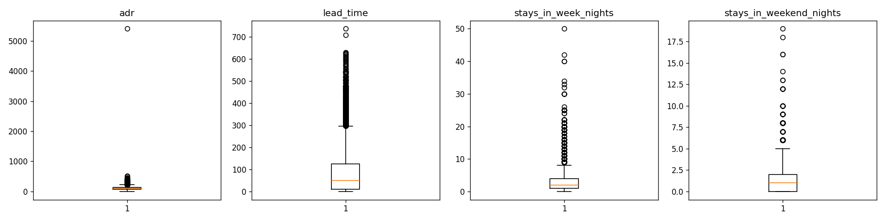
Figure 1: Distribution of key numeric columns before outlier treatment. Long whiskers and points above the box indicate right-skewed distributions with extreme high values.

5.3 Capping Extreme Values
Rather than deleting outlier rows, extreme values were capped (winsorized) to the IQR bounds using [Q1 − 1.5×IQR, Q3 + 1.5×IQR]. Values below the lower bound were raised to it, and values above the upper bound were reduced to it, preserving record count while limiting the influence of extreme values.
Column | Lower Bound | Upper Bound
adr | -20.52 | 226.88
lead_time | -160.00 | 296.00
stays_in_week_nights | -3.50 | 8.50
stays_in_weekend_nights | -3.00 | 5.00

5.4 Boxplots After Capping
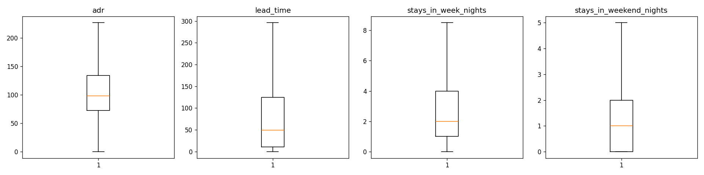
Figure 2: Distribution of the same columns after capping. Extreme values are constrained to the calculated bounds, tightening the spread while keeping all records in the dataset.

6. Data Type Conversion
Several columns were stored with data types that did not reflect their true nature. These were corrected to enable efficient storage, correct aggregation behavior, and proper chronological operations.
Conversion | Columns Affected | Reason
object → category | hotel, meal, country, market_segment, distribution_channel, reserved_room_type, assigned_room_type, deposit_type, customer_type, reservation_status | Categorical fields with a limited set of repeating values; category dtype reduces memory usage and speeds up group-by/filtering.
float64 → int64 | children, agent | Both represent whole-number counts/IDs. Once missing values were filled, float64 was no longer needed to accommodate NaN, so they were cast to integers.
3 columns → datetime64 | arrival_date_year, arrival_date_month, arrival_date_day_of_month → new arrival_date | Combining year, month, and day into one parsed date enables date-based filtering, sorting, and time-series analysis.

7. Feature Engineering
Four derived features were added to make the dataset easier to analyze without repeatedly recomputing common aggregates:
- total_guests — sum of adults, children, and babies, giving a single guest-count metric per booking.
- total_nights — sum of week-night and weekend-night stays, giving total length of stay.
- is_family — binary flag (1/0) indicating whether a booking includes any children or babies.
- booking_status — readable label ('Cancelled' / 'Not Cancelled') derived from the numeric is_canceled flag.

8. Post-Cleaning Validation
After all cleaning, type-conversion, and feature-engineering steps, the dataset was re-validated by re-running the same exploratory checks used at the start.
Metric | Before Cleaning | After Cleaning
Rows | 119,390 | 87,203
Columns | 32 | 36
Missing values (total) | 129,425 | 0
Duplicate rows | 31,994 | 0

The dataset now has zero missing values across all 36 columns, contains no duplicate rows, has consistent and appropriate data types, and includes four new engineered features — ready for downstream analysis or modeling.

9. Conclusion
The dataset was successfully cleaned and preprocessed through missing value handling, duplicate removal, outlier treatment, data type conversion, and feature engineering. It is now ready for exploratory analysis and predictive modeling.

